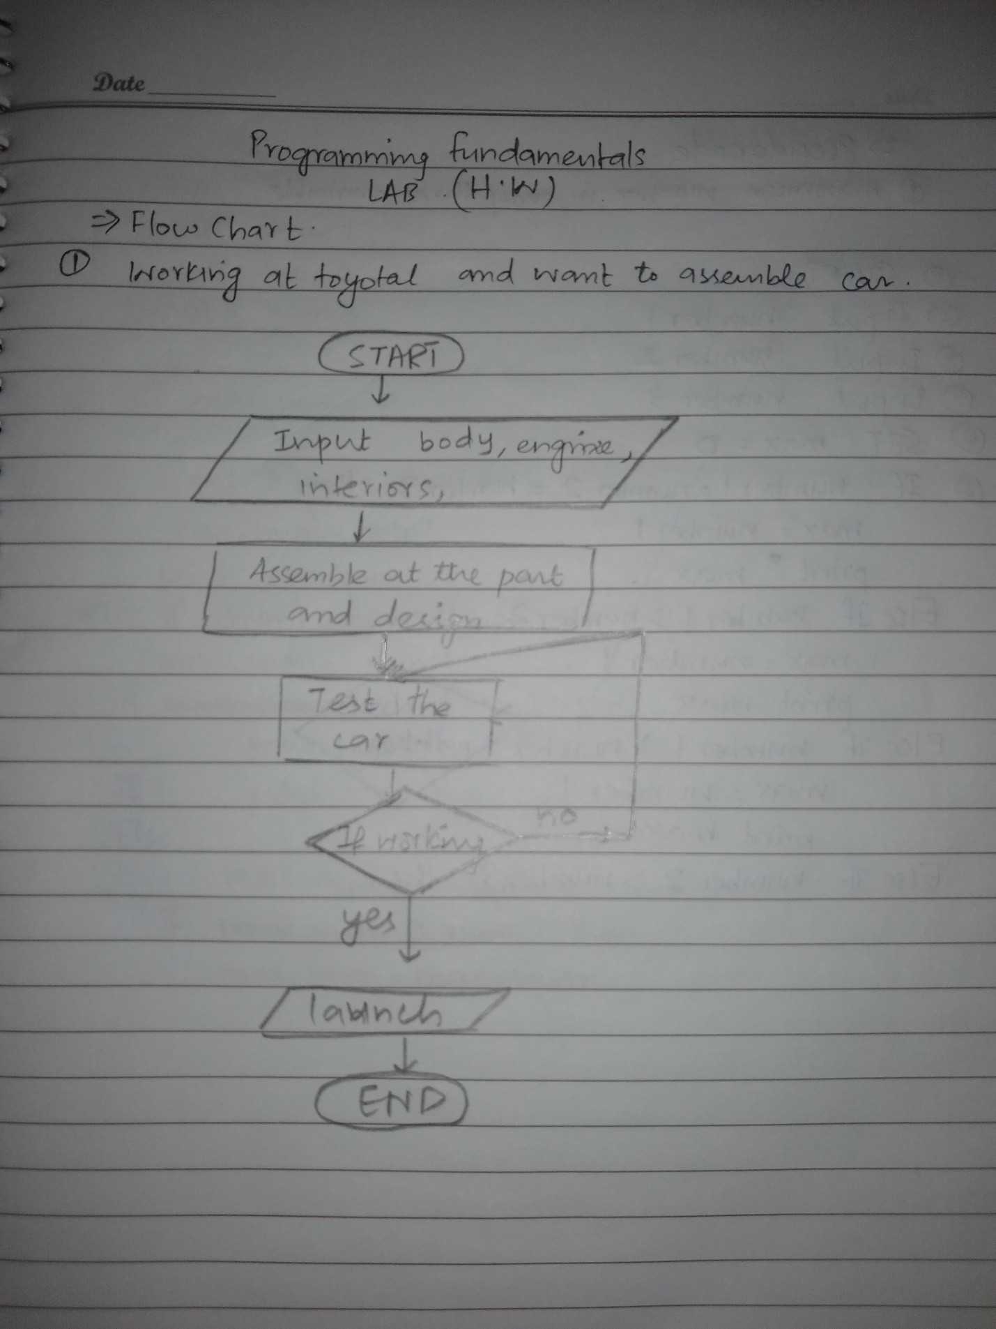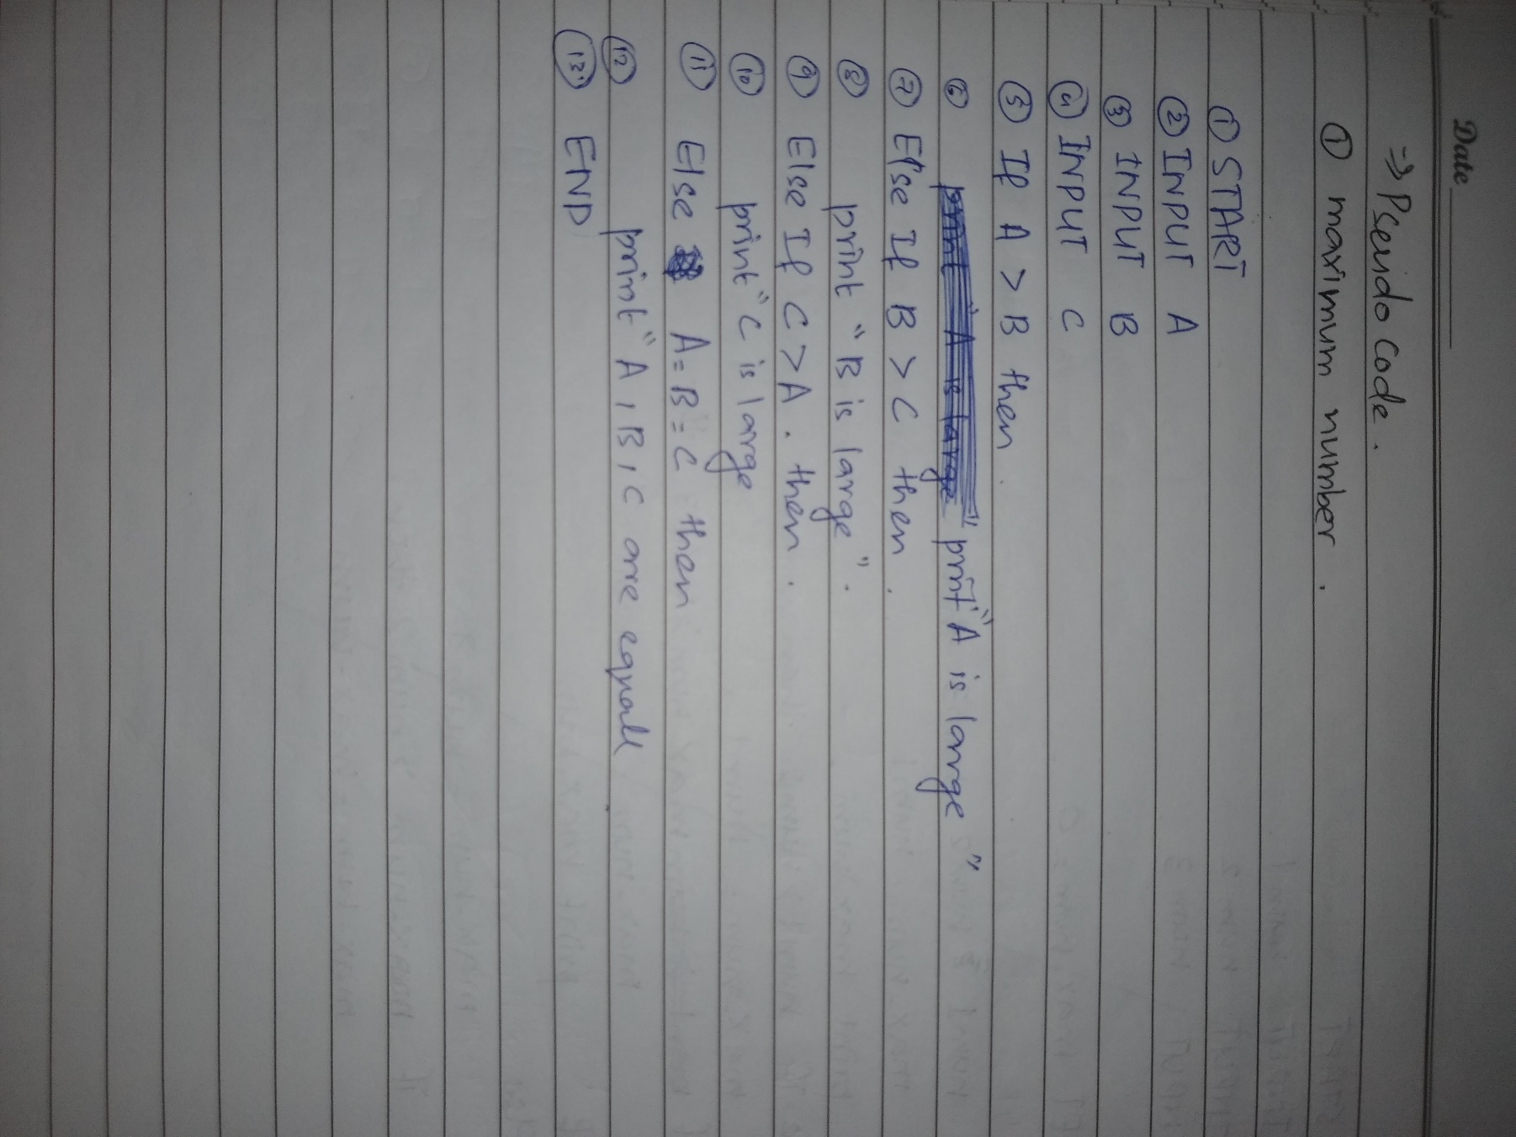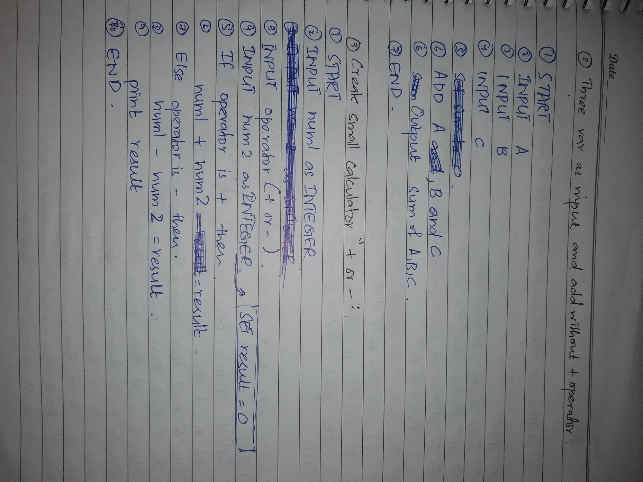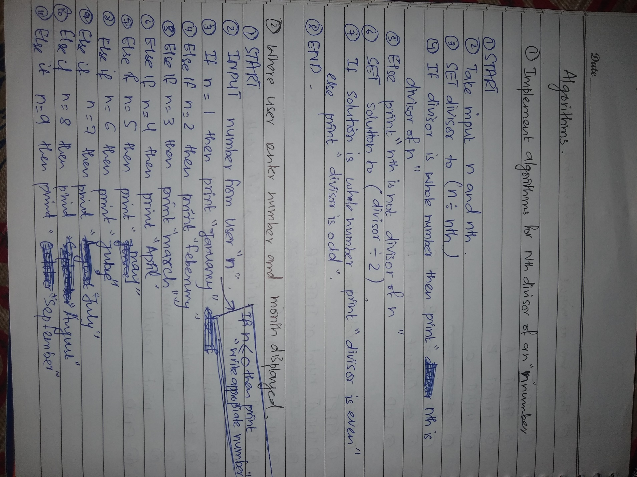

Flow Chart Q:1

Pseudo Code Q:1

Pseudo Code Q:2 and Q:3

Algorithms Q1 and Q2

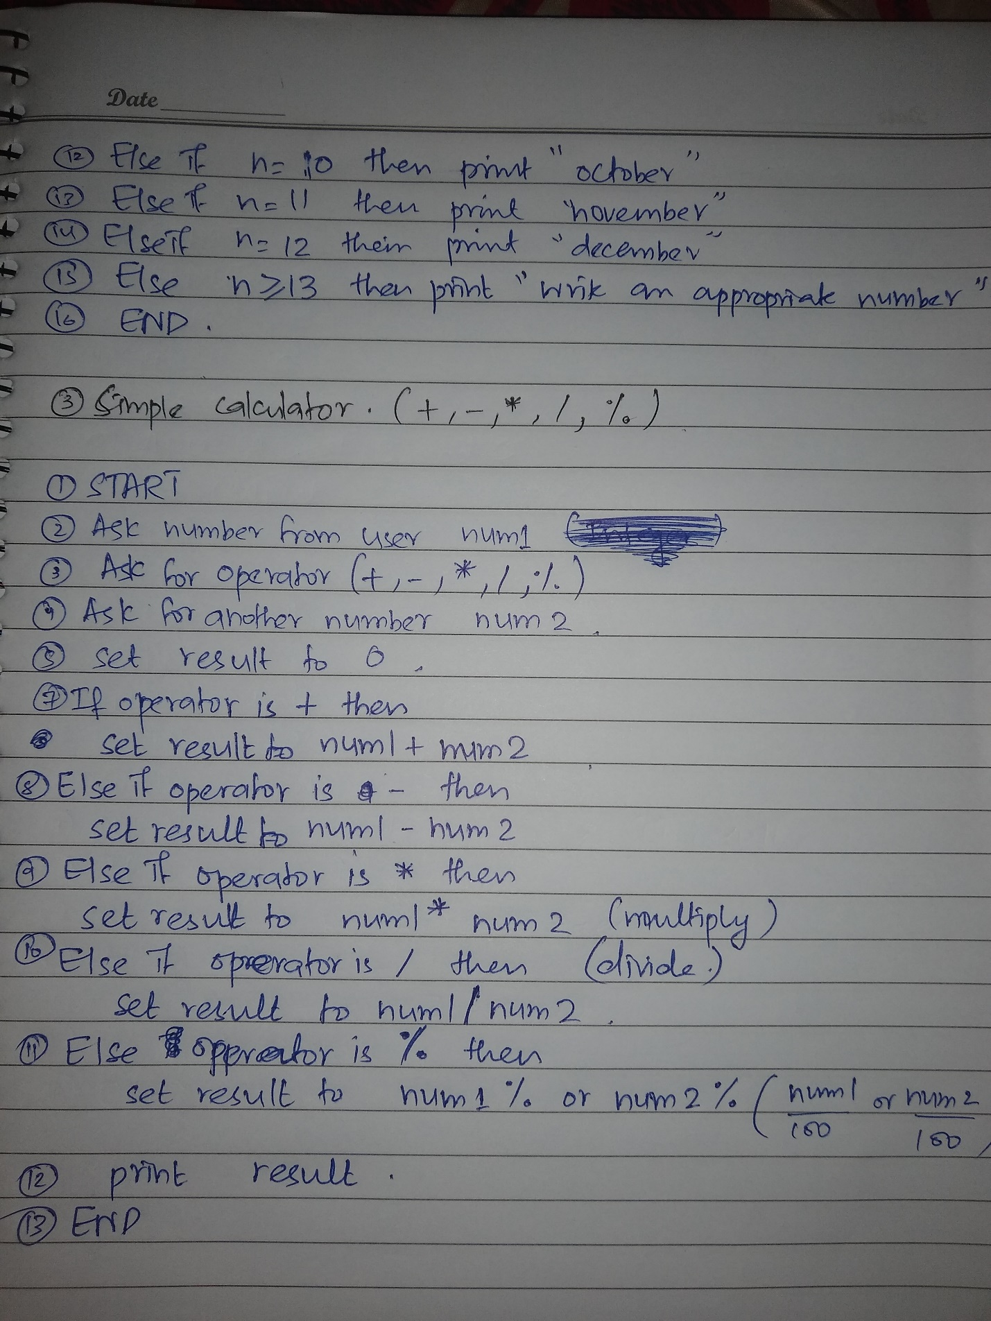

Github Link

https://github.com/Abuzar-mehdi283/24K-0630-Abuzar